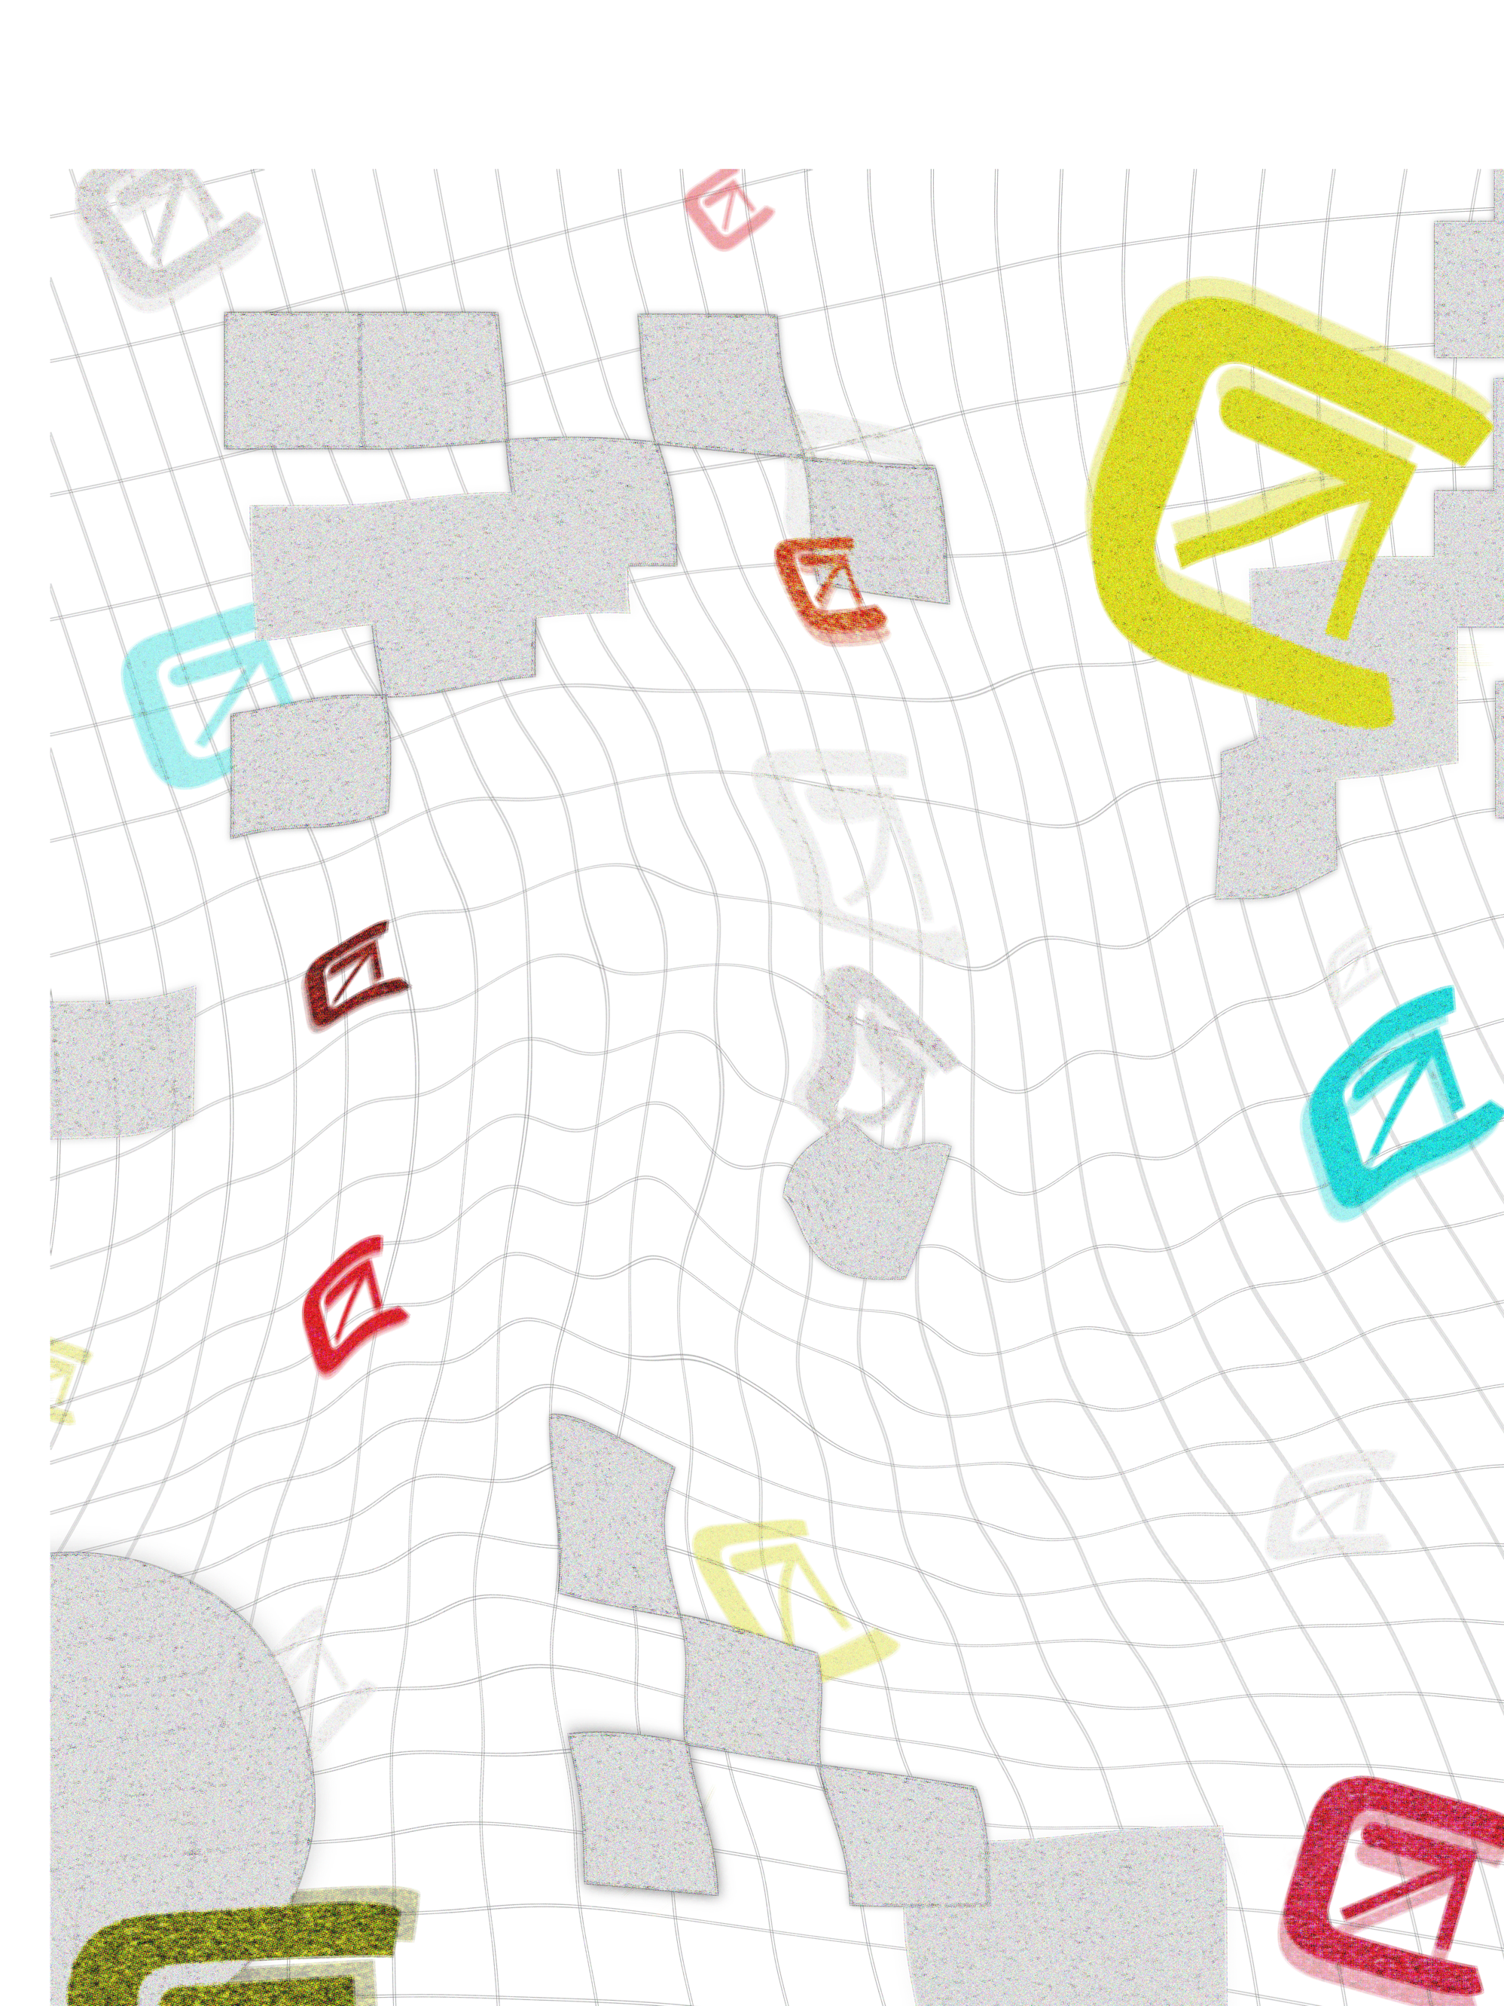



**­Annalise Wheeler**

**GIT 480 senior project: Trend Cycle**

**May 23, 2023- June 25, 2023**

**Concept:**

1

I will design a comprehensive brand identity for Trend Cycle, which includes a logo, visual elements, color palette, and brand voice. Additionally, I will develop and code a shopping website with four landing pages: Shopping/Home, Donation, About/Contact, and Shopping Cart.

Brand Voice: The brand voice for Trend Cycle should be youthful, inclusive, and enthusiastic. The tone should inspire creativity, promote community engagement, and emphasize the brand's commitment to sustainability and fashion-forwardness.

Implementations: The website development will involve coding HTML, CSS, and JavaScript to bring the design to life. The shopping cart functionality, cost calculator, field forms, and animations will be integrated into the website for a smooth user experience

Combining a strong brand identity with a well-designed and functional website will create a compelling online presence for Trend Cycle that resonates with the target audience and encourages active participation in shaping the brand's future design.

**Problems Solved:**

Trend Cycle addresses several key problems in the fashion industry and society, aiming to make a positive impact and inspire change among the younger generation. Here are the refined problem statements:

Environmental Impact: The fashion industry is known for its significant environmental footprint, including high levels of clothing waste and carbon emissions.

*Solution (*Environmental Impact*):* Trend Cycle aims to mitigate this problem by promoting sustainable practices and encouraging customers to prioritize reducing their clothing waste and carbon footprint.

Lack of Awareness: Many consumers, especially the younger audience, may not be fully aware of the environmental consequences associated with the fashion industry.

*Solution (Lack of Awareness):* Trend Cycle seeks to educate and raise awareness among its target audience about the importance of sustainable fashion choices and the need for responsible consumption.

Collaborating with smaller creators:

With the fashion industry evolving, gaining recognition on a platform as a designer can be difficult.

*Solution (Collab w/ small creators):* Trend Cycles platform facilitates collaborations between designers and allows them to showcase their designs. It would then be voted on the site based on what the next collab would be.

Lack of Responsibility: The fashion industry has been criticized for its lack of responsibility in addressing social and environmental issues.

*Solution (Lack of Resp.):* Trend Cycle strives to lead by example, promoting responsible practices such as inclusivity, diversity, and ethical sourcing. By doing so, the brand encourages other fashion industry players to prioritize these values as we

Through its sustainable approach, community engagement, and commitment to responsibility, Trend Cycle aims to create a positive impact and inspire the younger generation to embrace a more sustainable and conscious lifestyle, redefining the way we experience fashion.

**Thought Process:**

The development of the Trend Cycle brand concept was driven by a combination of professional aspirations, creative skills, and a genuine passion for sustainable fashion. Here is the refined thought process:

* Showcasing Graphic and Visual Design Skills: I wanted to focus on vibrant colors and abstract designs, I aimed to capture a unique aesthetic I refer to as "new retro." This direction allowed me to showcase my skills in creating visually engaging brand identities.
* Demonstrating HTML, CSS, and JavaScript Skills: When I start embedding code, I typically stick to the wireframes I build. However, I had to adjust the layout in some cases like this one. With these adjustments, I can spend more time adding animations and characters to the website rather than making more text content. When writing the code, I used Visual Studio Code and was first with the HTML, then CSS styling, and then the JavaScript file.
* Acting as a Creative Director: I embraced the role of overseeing and guiding the entire creative process. This position exemplified my ability to lead and execute a cohesive creative vision. Given the scale of this project, I dedicated a significant portion of my time, investing numerous days each week to its development and refinement.
* Love for Sustainable Fashion: The website promotes eco-friendly practices, reduces clothing waste, and raises awareness about the environmental impact of the fashion industry.

By combining these motivations and skill sets, the Trend Cycle brand concept was developed!

Reflection- *Brainstorming*:

During the initial ideation phase of the project, I found myself grappling with multiple ideas that I wanted to incorporate, making it challenging to determine the specific direction to pursue.

At the outset, I was enthusiastic about the possibility of creating intricate graphics and characters to enhance the website design. However, upon careful consideration of the project timeline and constraints, I decided to forego this idea to allocate my time more effectively.

I had envisioned developing five separate pages for the website, including an About page and a Creators page. However, upon evaluating the scope of the project and considering the time available, I decided to consolidate these two pages into a single page. This adjustment allowed for a more streamlined and efficient development process while still effectively conveying the desired information to the users.

2

**Identifying:**

As I continue this project, I have confidence in my ability to create a compelling brand identity and develop a functional 4-page website. The fact that the brand is non-existent gives me the freedom to explore and unleash my creativity without being bound by preconceived expectations.

When it comes to designing the website, I plan to draw inspiration from current e-commerce sites that have demonstrated successful UI/UX practices. By observing and analyzing their layouts, I can leverage proven design strategies and ensure a seamless user experience for visitors.

By combining my skills in branding, web design, and knowledge of effective e-commerce practices, I am confident in my ability to deliver a visually appealing and user-friendly website that aligns with industry standards and provides an enjoyable shopping experience for users.

For this project, I know I can create a brand identity and a 4-page website. Since the brand Is non-existent, I do not have to limit my creativity or have set expectations. When it comes to designing the website, I will implement based on current e-commerce sites. I will design a layout that shows proven UI/UX success.

Due to time constraints, conducting user testing for the final website may not be feasible. Instead, I will rely on my design and implementation skills, which are informed by extensive research conducted through various online resources. Although user testing is an important step in the development process, I will ensure that the website's design and functionality align with industry best practices and user-centered principles based on the knowledge I have gathered. While it would have been ideal to conduct user testing, I will strive to create a website that is intuitive, user-friendly, and meets the needs and expectations of the target audience to the best of my abilities.

Reflection-*Identify*:

During the process of creating a brand identity, one of the key tasks was selecting appropriate symbols and aesthetics. However, due to time constraints, I opted not to create graphic art designs. Instead, I decided to enhance the website with an abundance of carefully chosen photos to bring out the desired creative appeal. Finding free stock photos that aligned with my vision proved to be challenging, which was an unexpected obstacle in establishing a brand from scratch. Nevertheless, upon reflecting on the experience, I firmly believe that creating a brand that didn't previously exist was the right decision.

3

**Define:**

Project: Create a brand identity for Trend Cycle including a logo, visual elements, color palette, brand voice, and digital assets. Develop and code a shopping website with 4 landing pages.

Milestones Achieved: *Visual Aesthetics and Initial Website Development*

As of June 16, 2024, I have accomplished significant milestones in the project. I have successfully finalized the color palette, and font selection, and created a captivating logo that aligns with the desired visual aesthetics. Moreover, I have made substantial progress in website development, having completed the first four pages. This includes the incorporation of engaging photos, compelling text, thoughtfully designed graphics, and even some tasteful animations. The layout has been carefully crafted to ensure an immersive and seamless user experience. These achievements mark important strides in bringing the Trend Cycle project to life.

Inspiration:

In developing the platform, I drew significant inspiration from TikTok and Amazon, both in terms of their overall aesthetic and the layout of their platforms. TikTok's ability to capture attention through short, engaging videos and Amazon's vast marketplace served as valuable references for creating an appealing and user-friendly experience on Trend Cycle.

For fashion designers who sign up on social media platforms, their success often depends on effectively marketing their designs to sustain their careers. Building a community and establishing a customer base takes time and effort. With Trend Cycle, the platform aims to address this challenge by providing a diverse and continuously updated shop that regularly showcases new designers and products. Unlike platforms that cater to a specific set of people or design aesthetics, Trend Cycle's focus is on inclusivity and variety.

By consistently featuring new designers and their unique products, Trend Cycle ensures that the platform remains dynamic and exciting for users. This approach also opens opportunities for emerging designers to gain exposure and reach a broader audience, fostering a sense of community and collaboration within the fashion industry.

In summary, the platform's goal is to provide a sustainable career path for fashion designers by offering a diverse shop that continuously introduces new designers and products. By embracing inclusivity and variety, Trend Cycle aims to create an engaging and supportive community for designers and users alike.

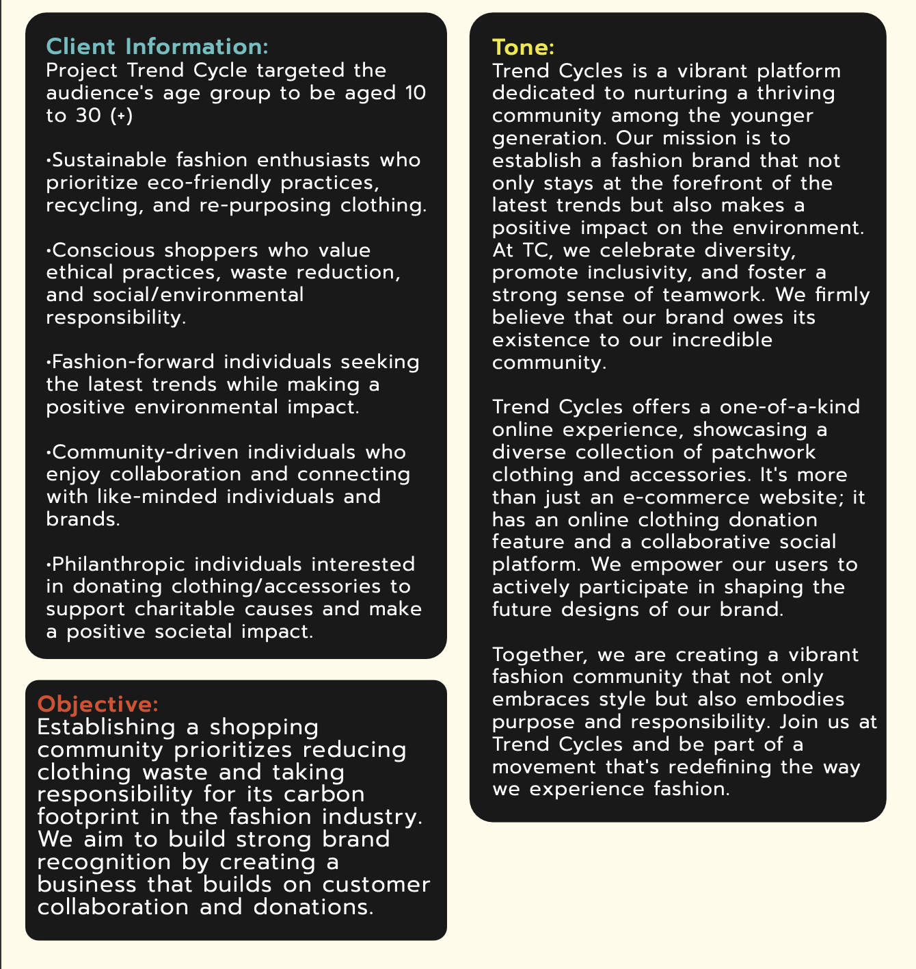

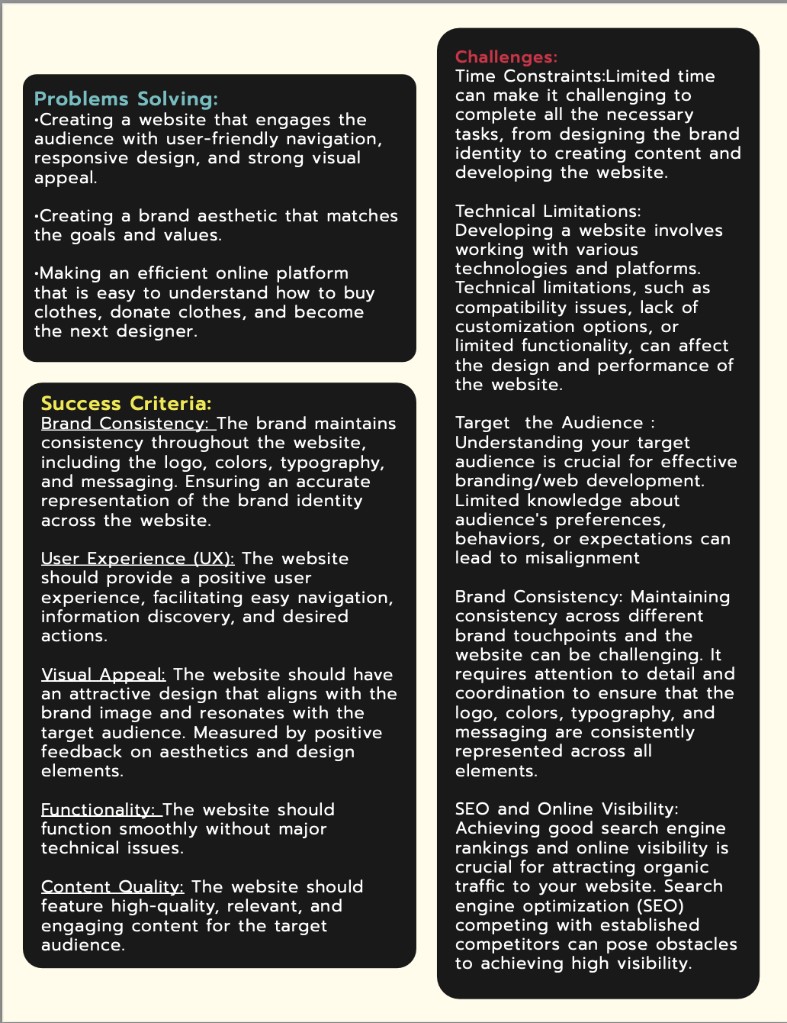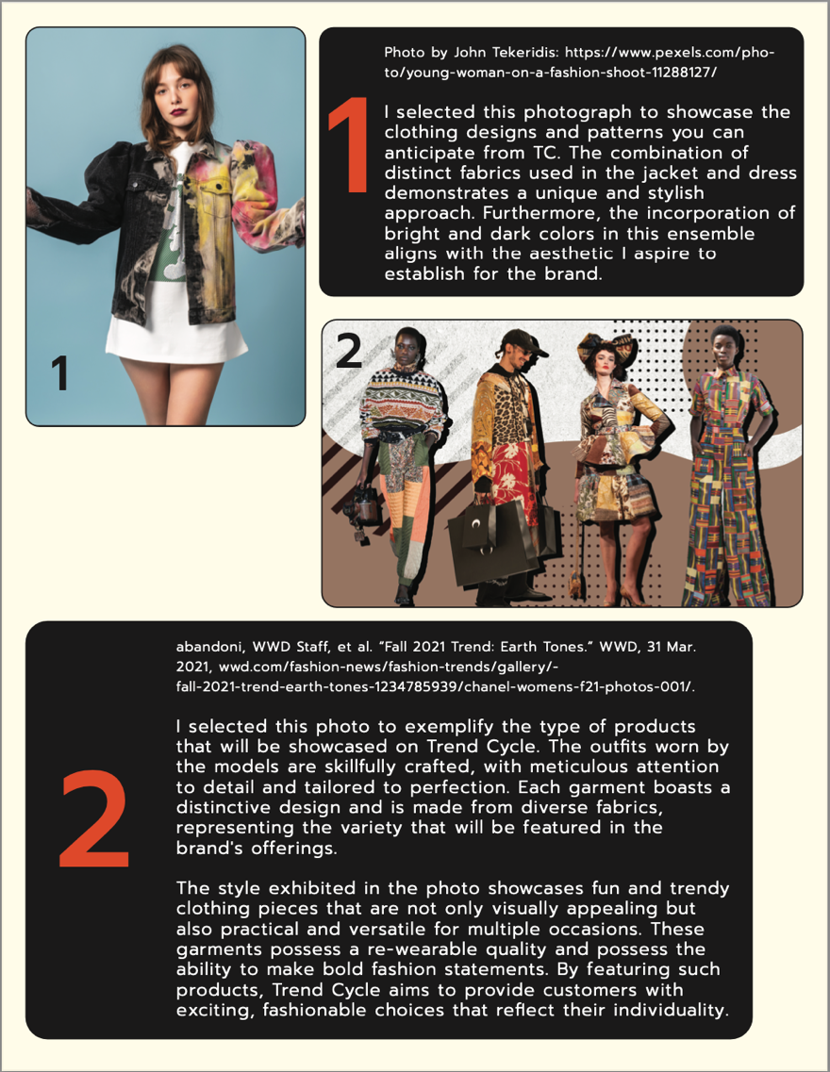

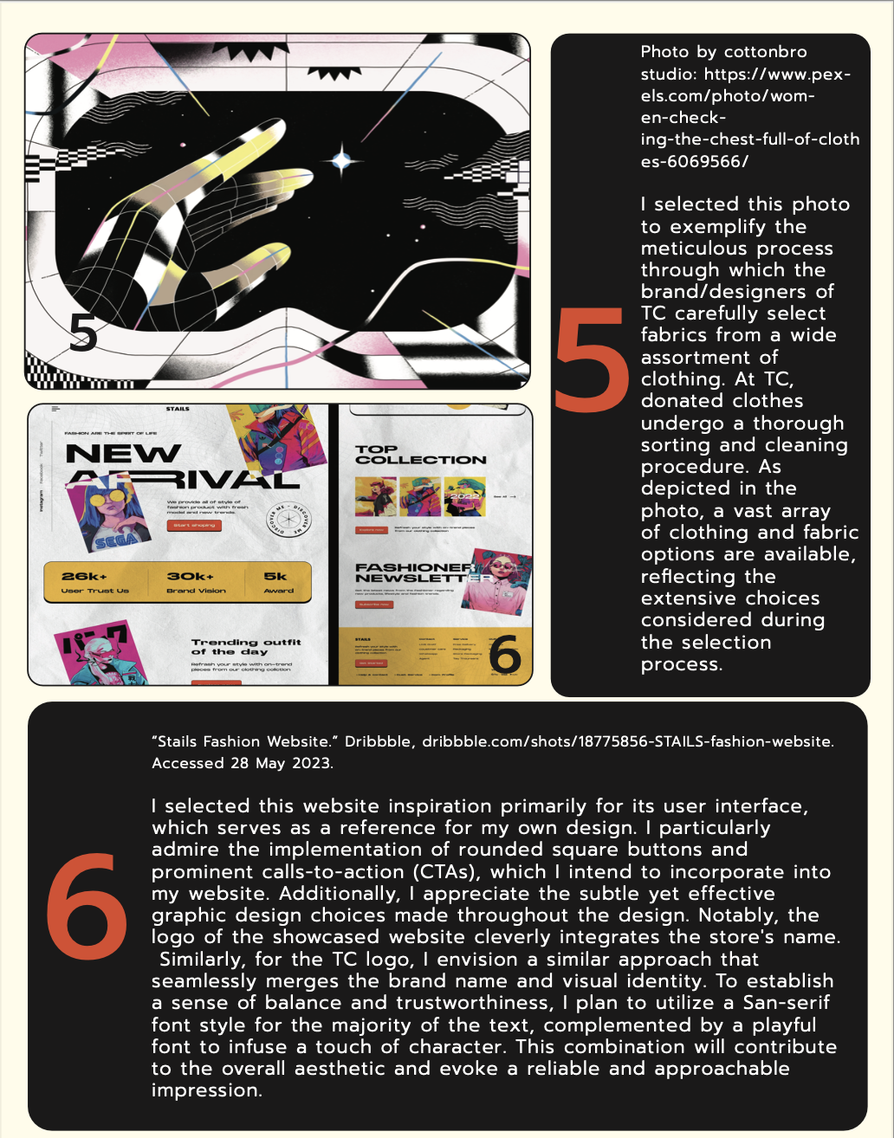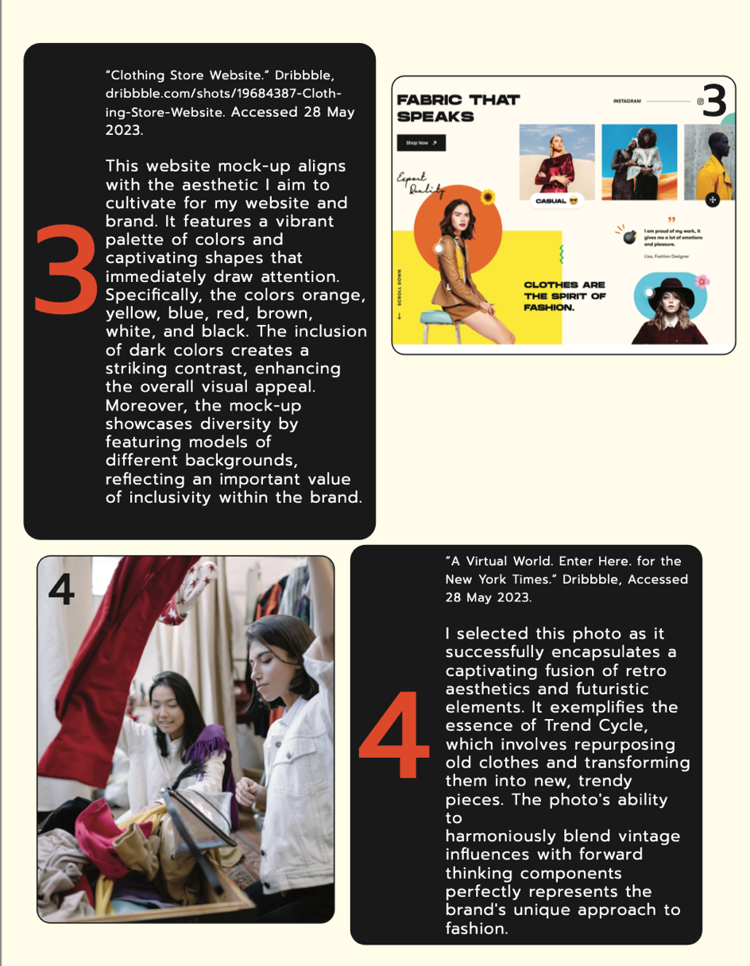

Reflection-*define*:

I have successfully adhered to the timeline up to this point by effectively setting specific deadlines for completing tasks. However, I have encountered a challenge in integrating all my ideas seamlessly into the project. While I have generated numerous creative concepts, it has been a task to ensure they are implemented cohesively without compromising the overall design and functionality of the project. Despite this obstacle, I am committed to finding innovative solutions and striking a balance between incorporating my ideas and maintaining a smooth user experience. By leveraging my problem-solving skills and employing effective design strategies, I

will strive to overcome this challenge and deliver a final product that reflects both my creativity and usability standards.

4

**Ideate**

Elevating Branding and Website Design: *Embodying the Essence of Recycled Vintage Fashion*

Throughout the creation of this project, my mind was continuously filled with ideas on how to visually capture the essence of recycling vintage clothes for new high-fashion looks. This concept served as the driving force behind the branding and website design. With careful consideration, I invested a significant amount of time in selecting the perfect colors, photos, and graphic elements that would resonate with the brand's identity. The goal was to create a cohesive and captivating online experience that truly embodies the unique spirit of repurposed fashion. I used Adobe Illustrator and Photoshop to create graphics and edit the appearance.

.



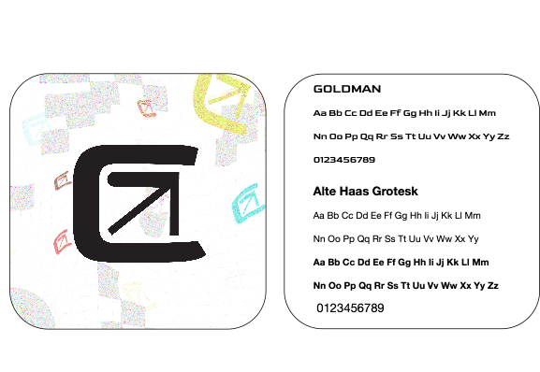

Font Choice: Deliberating on font choices for the Trend Cycle, I carefully selected two fonts that prioritize readability while offering distinct styles that harmonize with each other and the aesthetic. Next, you’ll see sketches that I did when producing the logo and graphics. I created these sketches with my iPad on the app Nebo.

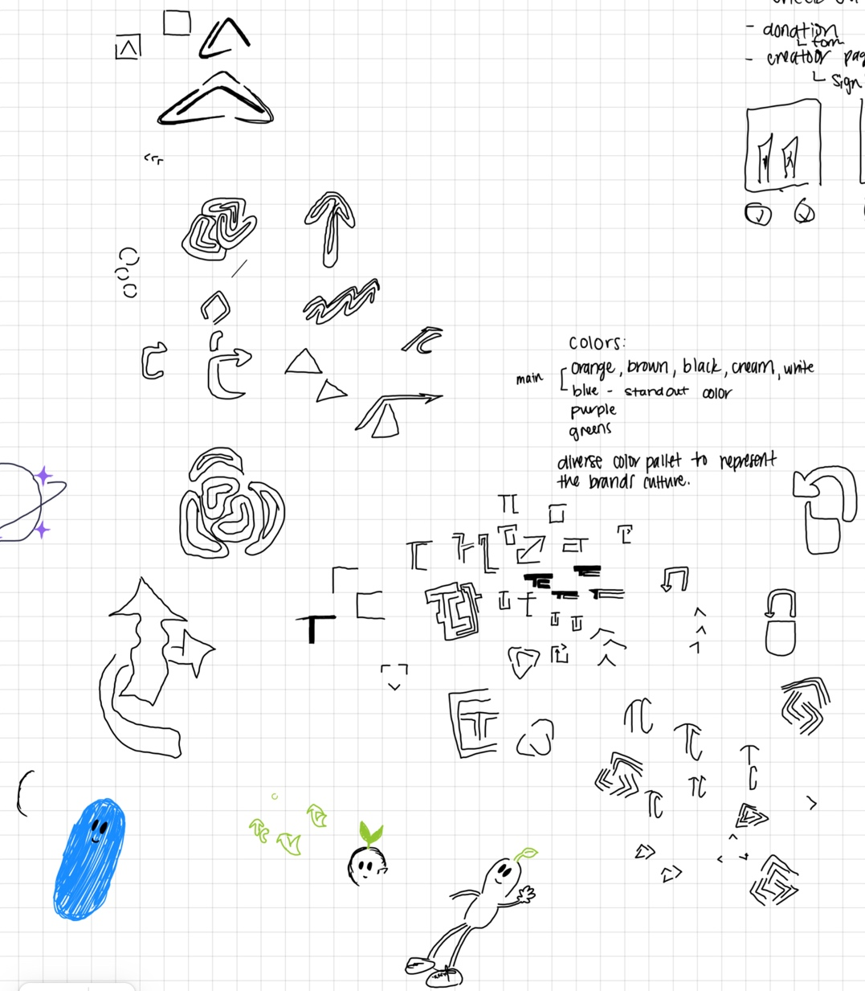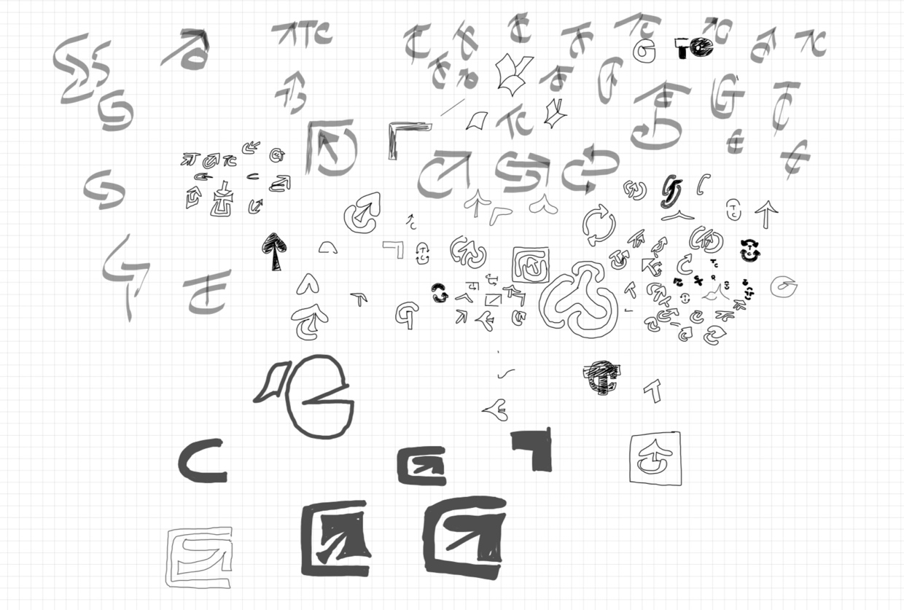

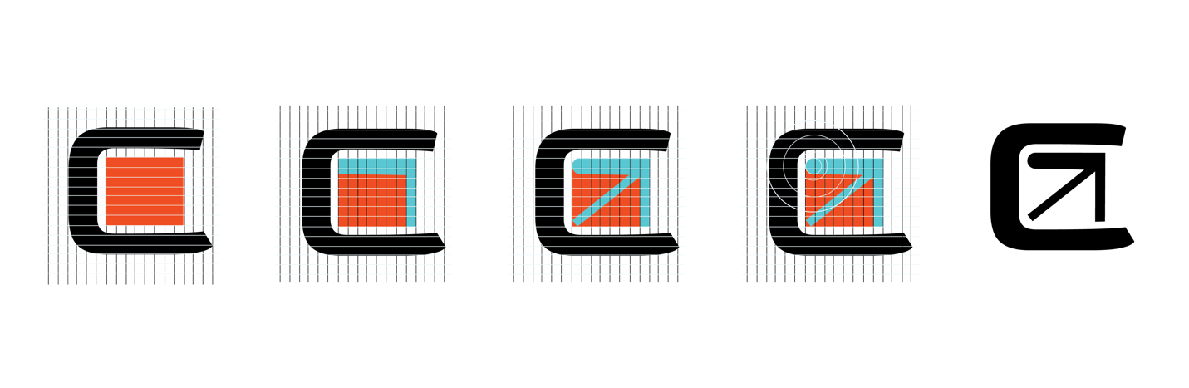

The Logo Process: A sleek and minimalist combination of the letter 'C' and an arrow, where the arrow is formed by utilizing half of the letter 'T'. This deliberate design choice was made to achieve a contemporary and clean appearance. The arrow within the logo carries a symbolic representation of the company's growth, mirroring the upward trajectory depicted on a graph. It serves as a visual metaphor, illustrating the progress and advancement the company aims to achieve. The arrow was also inspired by the Recycling logo where you commonly see three arrows.

Icons for website:



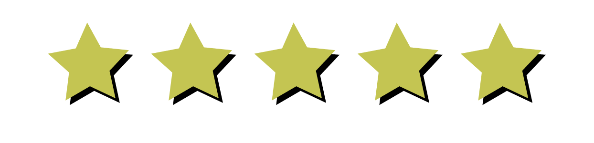

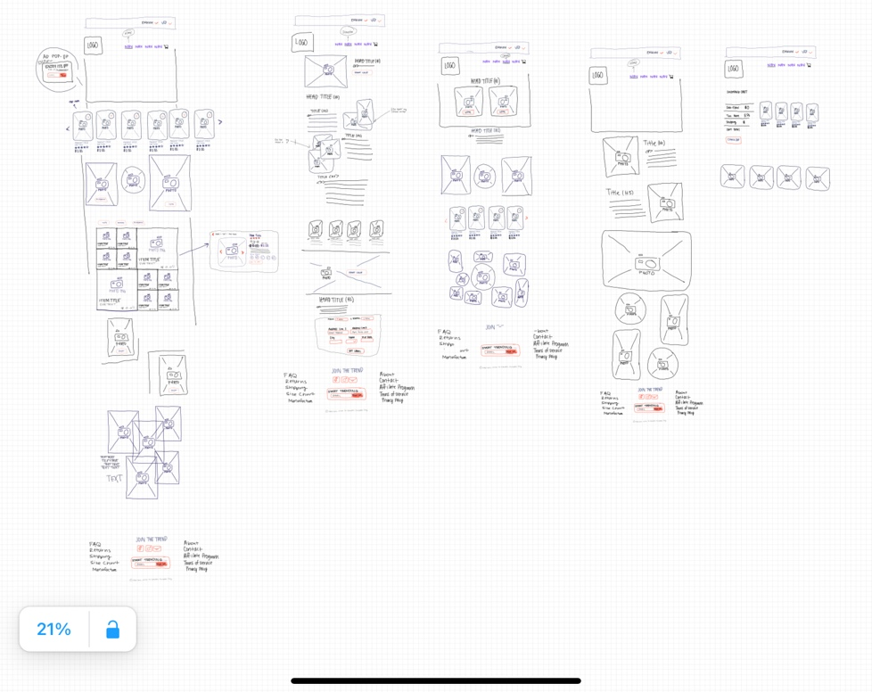**Wireframe Sketches:**

In this first sketch, I mainly was deciding what elements I wanted to include and what I can implement.

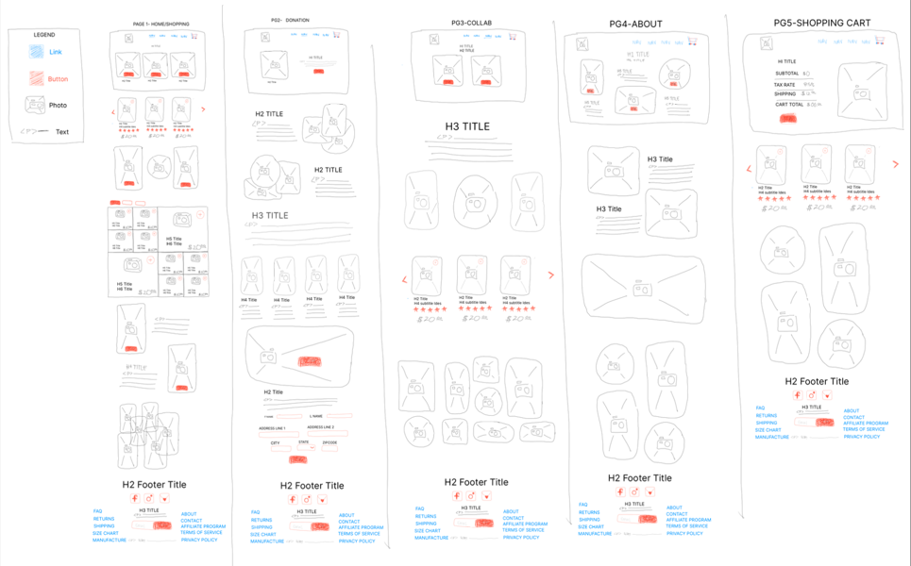

This next sketch is what I had originally been planning and turned in to my peers to evaluate. Considering the timeline and goals I have, I decided to change the layout.

I want to make sure the rest of my time goes to making the website an experience. Having a lot of okay content doesn’t make the project better.

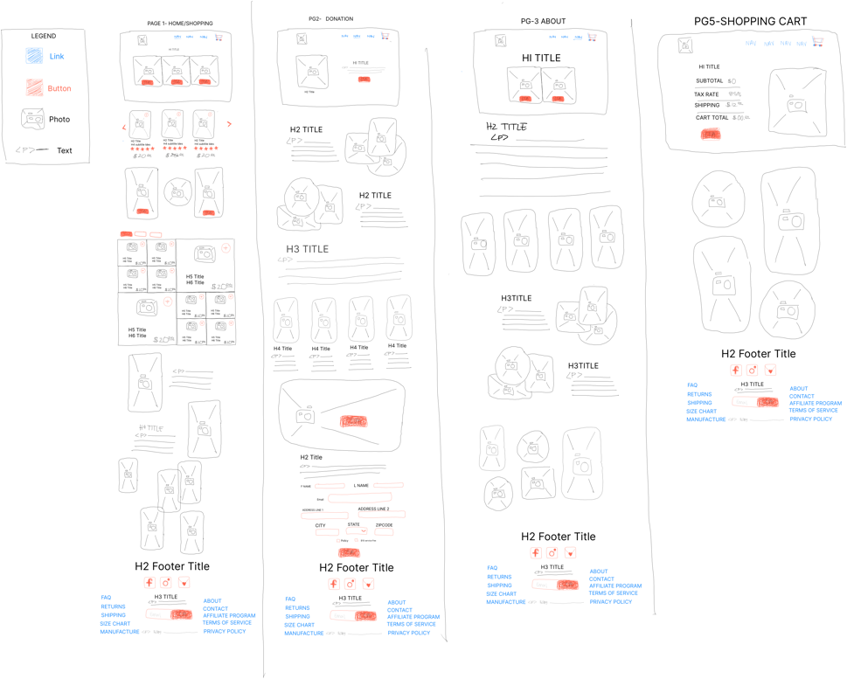

This is the updated wireframe that I have decided on thus far.

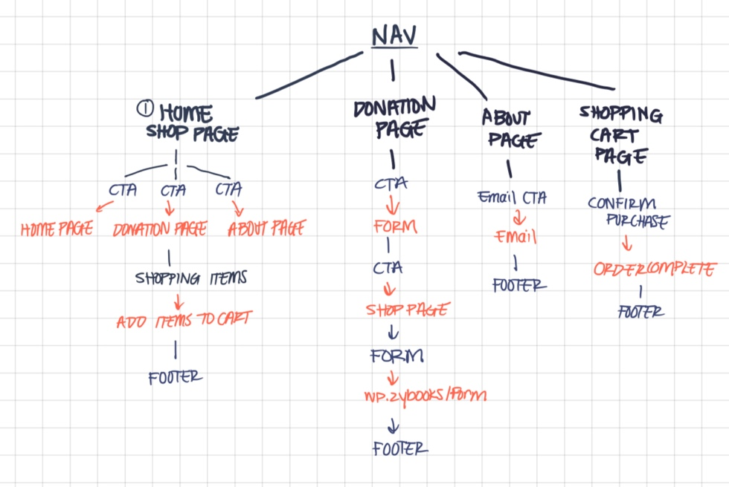

Site map:

This is the sitemap for the website thus far.

Reflection-*Design Process*:

In the quest for the perfect fonts, I initially sought a vibrant and classic combination to create the desired contrast. However, upon considering the vibrant colors and photos that adorn the website, I realized the significance of not overshadowing the content. Thus, I made a conscious decision to opt for fonts that strike a delicate balance. These fonts not only enhance readability but also seamlessly complement the overall aesthetic, ensuring they do not detract from the website's core message. While creating the graphics and aesthetics posed its challenges, I am pleased with the overall direction I have achieved thus far.

Looking ahead, I am determined to follow the established timeline, ensuring the completion of the project's remaining steps. With each milestone, I will continue to refine and bring the vision to life, ultimately delivering a cohesive and captivating experience for users.

Website Progress: (photo on next page)

The quality is the best state without making the file too large.

**Prototype:**

5

During the development of this website, I utilized Visual Studio Code as my code editor and the Google Chrome live extension server for code testing. To ensure the proper functionality and appearance of the website, I followed a structured approach based on wireframes that I had initially sketched out. Here's an overview of the development process:

HTML Pages:

I began by creating the HTML pages, which serve as the foundation of the website's structure. This involved organizing the content, defining the layout, and incorporating essential elements such as headers, footers, navigation menus, and sections for different page components.

CSS Styling:

Once the HTML structure was in place, I proceeded with styling the website using CSS. This step involved defining the visual aspects, including colors, fonts, spacing, and positioning of various elements. CSS allowed me to enhance the aesthetics and ensure consistency across different pages.

JavaScript Functionality:

After establishing the HTML and CSS groundwork, I incorporated JavaScript to add interactive features and functionality to the website. One specific feature I implemented was a shopping cart, which enabled users to add and remove items. Using JavaScript, I created the necessary code to handle user interactions, update the cart contents dynamically, and perform the corresponding actions.

By following this development process and utilizing Visual Studio Code, Google Chrome live extension server, HTML, CSS, and JavaScript, I was able to create a fully functional website with a structured layout, appealing design, and interactive features such as a shopping cart.

**Obstacles:** During the development of this website, I encountered a couple of challenges that required my attention and effort. The most significant obstacle I faced was ensuring the responsiveness of the website across multiple screen platforms. Additionally, I had some uncertainties regarding the placement of images and text. Here's how I addressed these challenges:

Responsive Design:

Achieving responsiveness across various screen sizes and platforms can be complex. To overcome this challenge, I employed several techniques and practices. Firstly, I utilized CSS media queries to apply different styles and layouts based on the screen size. This allowed me to optimize the website's appearance and functionality for desktops, laptops, tablets, and mobile devices. Secondly, I extensively tested the website on different devices and screen sizes to identify any layout or display issues. Through iterative testing and adjustments, I was able to ensure a consistent and user-friendly experience across various platforms.

Placement of Images and Text:

Determining the optimal placement of images and text is crucial for an aesthetically pleasing and user-friendly design. To address my uncertainties, I considered the principles of visual hierarchy and user experience. I focused on creating a logical flow of information and ensuring that important content is prominently displayed. I experimented with different placements, considering factors such as readability, balance, and overall design aesthetics. Additionally, I sought feedback from colleagues or potential users to gather insights and make informed decisions about the placement of images and text. By iterating on the design and incorporating feedback, I was able to find a visually appealing and effective arrangement of elements.

*“Did your chosen development process work for the project?”*

Reflection-*Prototype****:***

By implementing a well-structured process and creating a timeline, I successfully achieved my desired goals within the allocated time frame. The process provided me with clarity and direction, while the timeline ensured that I stayed on track and managed my time effectively. However, I identified an area for improvement in my project management approach, particularly in maintaining consistency with a single idea and avoiding excessive changes. Going forward, I aim to strengthen my focus and decision-making skills, ensuring that I stay committed to the initial concept and minimize unnecessary alterations, allowing for smoother and more efficient execution.

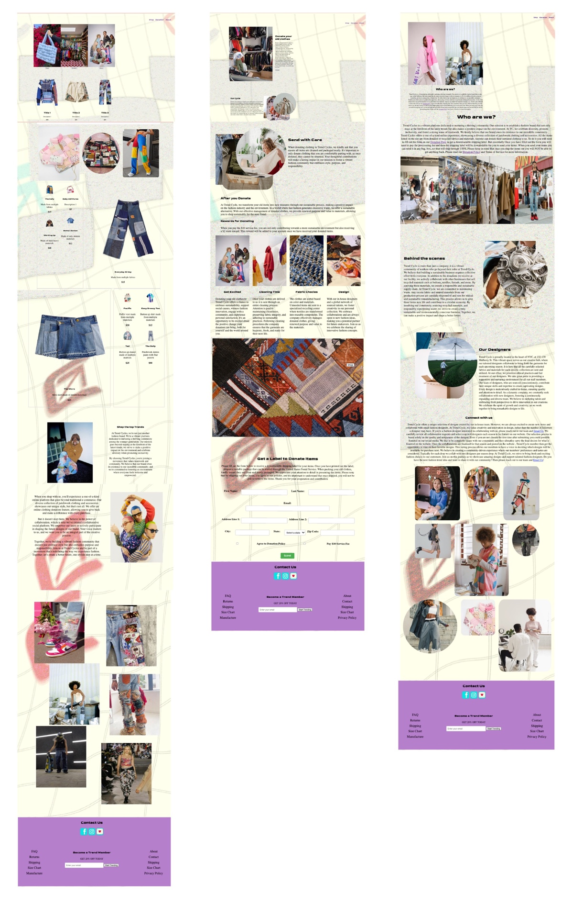**Test:**

6

*“Present the latest prototype/version to peers for feedback”*

This photo is where I was on June 20th.

Feedback from a few Peers:

“Hello Annalise, Strengths: I believe the overall design of your website exudes a remarkable sense of creativity, capturing an artistic charisma that aligns well with the purpose of showcasing a clothing designer's work.

Weaknesses: The background image appears to be overwhelming, and the text seems very wordy

Improvement: To enhance the visual appeal of your website, you might consider changing the background image or adjusting its colors. I noticed that while browsing your website, my attention was frequently diverted, causing distractions. Additionally, the paragraphs of text appeared somewhat monotonous. You could incorporate lines or use bolded words within the text to make it more engaging and approachable for readers.

However I think the website is fun, and it's different than other bland websites, so I hope my feedback helps in some way, best of luck with your final drafts!”

“Hi Annalise! This project looks so fun!

Strengths of the project draft

Really great design, lots of fantastic high-quality images, and overall a cool and interesting concept!

Weakness of the project draft

I think that taking the time to really center your layout and make sure that your photos are complementary in size and spacing will really add to the professionalism of your website.

Feedback for improvement

I love the busyness of this mockup, and I think that's exactly what you're going for, but I would suggest creating a higher contrast between the background of your site and the text/contact form. This could be achieved by lightening to background, adding boxes behind the text, etc. I think it just needs a teensy bit more separation from your background image.

Great job so far!”

“Hi Annalise, great work so far! I love how this project really shows off your creative side. A huge strength is your uniqueness, I think it looks awesome. One weakness I would say is your text descriptions. I know if I saw this for the first time, I would skim over it. One area of improvement is to shorten up that text and make it a big bigger to add some eye catching phrases to gain attention and retention. But other than that, awesome work!”

Reflection-*Test*:

During the creation of this website, I did not have the opportunity to conduct user testing. However, I actively sought feedback from peers and my immediate environment, taking their input into consideration. To ensure the quality and standards compliance of my code, I utilized various resources throughout the development process. I made use of tools like the W3C markup service to validate and correct any potential errors or issues in my HTML and CSS code. Additionally, I referred to trusted sources such as W3schools and Developer mozilla for guidance on semantic coding practices and to ensure my code was optimized for search engine optimization (SEO). By leveraging these resources, I ensured that my code adhered to industry standards is semantic and SEO-optimized.

**Refine:**

7

Changes made from the initial second peer review:

Initially, my focus was on ensuring an ample amount of content for the website. However, during the refinement phase, I carefully reviewed and revised the content. I adjusted the format, spacing, and design, aiming to streamline the overall presentation. By doing so, I reduced the amount of text, ensuring a concise and visually appealing website that effectively conveys the desired message.

Changes I decided to also include:

During the initial design phase of the website, I faced challenges in visualizing how the layout would appear on different screens. While I had a clear aesthetic vision in mind, I struggled to fully execute it until the later stages of the design process. However, as the design evolved, I gained a better understanding of how to achieve the desired format and successfully implemented it by the end. Through iterative adjustments and testing, I was able to refine the design and achieve the desired visual outcome, ensuring that the website looked appealing and functioned well across various screen sizes.

Reflection-*Refine*:

In hindsight, I realize that I should have given more consideration to designing the website with responsiveness in mind, specifically for multiple screen sizes. Although I was initially focused on creating a website rather than an app, I overlooked the fact that websites are still accessed on mobile screens. By being more thoughtful about responsive design from the start, I could have developed the website more efficiently. Taking into account the various screen sizes and designing with responsiveness in mind would have allowed for a faster and smoother development process.

**Implement:**

8

From the project's inception, I was aware of the extensive workload ahead and set ambitious goals for myself. Now that I have successfully completed the project, I am delighted with the outcomes achieved. I take pride in creating a distinctive and thoughtful web design that adheres to semantic principles. Moreover, I believe the careful selection of photos, designs, graphics, and other elements successfully harmonizes to establish a cohesive brand identity. These accomplishments contribute to my overall satisfaction with the project's results.

Reflection-*Implementation*:

As a graphic designer, staying up to date with the latest trends and designs can be challenging, especially when faced with the added pressure of personal opinions and external judgments. Initially, when I ventured into crafting the brand's identity and determining its visual direction, I found the process overwhelming. However, I managed to navigate through it and achieve success. Nonetheless, throughout this experience, I discovered that I don't derive as much enjoyment from creating without a specific framework or starting point for a brand. As my own project manager, I demonstrated strong capabilities in setting and achieving goals. I excelled in effectively managing the project, ensuring that tasks were completed within the established timeline. While some changes were made from the initial sketches, I remained committed to the timeline and successfully accomplished all the major working parts of the project. This proficiency in project management allowed me to stay focused and deliver a completed project in a timely manner.

Works Cited

“8 Ethical Companies That Recycle Clothes (+fashion Waste).” *Recycle Coach*, 17 May 2023, recyclecoach.com/blog/8-ethical-companies-that-recycle-clothes-fashion-waste/.

“About Us.” *Remake*, 11 May 2023, remake.world/about-us/.

“Activate Cleanout Bag.” *thredUP*, www.thredup.com/cleanout/activate. Accessed 15 June 2023.

*African American Fashion Woman Wearing Patchwork Jeans and Corset - Pexels*, www.pexels.com/photo/african-american-fashion-woman-wearing-patchwork-jeans-and-corset-12610340/. Accessed 15 June 2023.

*Amazon.Com: Aelfric Eden Star Patchwork Casual Denim Jeans Unisex ...*, www.amazon.com/Aelfric-Eden-Patchwork-Streetwear-Trousers/dp/B0BC1PGXZB. Accessed 15 June 2023.

Behance. “Abstract Geometric Vector Shapes Pack 300+ Elements.” *Behance*, www.behance.net/gallery/133128957/Abstract-Geometric-Vector-Shapes-Pack-300-elements. Accessed 15 June 2023.

Behance. “ScanPay.” *Behance*, www.behance.net/gallery/170591781/ScanPay. Accessed 15 June 2023.

Behance. “Superfiliate.” *Behance*, www.behance.net/gallery/161693627/SUPERFILIATE. Accessed 15 June 2023.

*Black Teenager Choosing Clothes in Bedroom · Free Stock Photo*, www.pexels.com/photo/black-teenager-choosing-clothes-in-bedroom-4545966/. Accessed 15 June 2023.

Bodnar, Ethan. “Photo by Ethan Bodnar on Unsplash.” *White Textile Lot Photo – Free Pattern Image on Unsplash*, 19 Aug. 2018, unsplash.com/photos/kgC99X3WH1w?utm_source=unsplash&utm_medium=referral&utm_content=creditCopyText.

“Casual Cute Patchwork Jacket.” *Kclot*, kclot.com/products/casual-cute-patchwork-jacket?currency=USD&variant=41126397870240&utm_medium=cpc&utm_source=google&utm_campaign=Google+Shopping&gclid=CjwKCAjwp6CkBhB_EiwAlQVyxWrykwdbsCWqSa9_XhJm2znnBKknTsQ_NyS6t4SvD5eUj8RDQjFlTxoCMgYQAvD_BwE. Accessed 15 June 2023.

*Crop Person Packing Jeans into Carton Container - Pexels*, www.pexels.com/photo/crop-person-packing-jeans-into-carton-container-4498143/. Accessed 15 June 2023.

*Crop Woman Sketching on Paper · Free Stock Photo - PEXELS*, www.pexels.com/photo/crop-woman-sketching-on-paper-7148060/. Accessed 15 June 2023.

“CSS Validation Service.” *The W3C CSS Validation Service*, jigsaw.w3.org/css-validator/#validate_by_upload. Accessed 24 June 2023.

CzechCEO, Pete. “The Timeline of Creating a Successful Website – Development, Launch and Beyond.” *NP Group*, 5 July 2022, www.npgroup.net/blog/the-timeline-of-creating-a-successful-website-development-launch-and-beyond/.

*A Fashionable Man Projecting on the Camera While Looking Afar*, www.pexels.com/photo/a-fashionable-man-projecting-on-the-camera-while-looking-afar-7828112/. Accessed 15 June 2023.

*Fashionable Young Man and Woman at a Skatepark · Free Stock Photo - PEXELS*, www.pexels.com/photo/fashionable-young-man-and-woman-at-a-skatepark-8973501/. Accessed 15 June 2023.

*Free Stock Photo of Adult, at Work, Business, Chair ... - Pexels*, www.pexels.com/photo/man-people-woman-relaxation-9909078/. Accessed 15 June 2023.

Hirose, Alyssa. “114 Social Media Demographics That Matter to Marketers in 2023.” *Social Media Marketing & Management Dashboard*, 2 Dec. 2022, blog.hootsuite.com/social-media-demographics/.

Hirose, Alyssa. “114 Social Media Demographics That Matter to Marketers in 2023.” *Social Media Marketing & Management Dashboard*, 2 Dec. 2022, blog.hootsuite.com/social-media-demographics/.

“Hooked for Life Publishing (Mbtemple) - Profile.” *Pinterest*, www.pinterest.com/mbtemple/. Accessed 15 June 2023.

“How to Choose the Right Social Media Platform to Reach Your Target Audience.” *Exposure*, 10 Mar. 2020, www.exposure.com/blog/most-popular-social-media-platforms-by-total-users-age-and-gender/.

*HTML Tutorial*, www.w3schools.com/html/. Accessed 24 June 2023.

June, Yasamine. “Photo by Yasamine June on Unsplash.” *A Man Standing on a Sidewalk in Front of a Store Photo – Free Berkeley Image on Unsplash*, 22 Oct. 2021, unsplash.com/photos/LoudILFJDG0?utm_source=unsplash&utm_medium=referral&utm_content=creditCopyText.

Lagan, Quaid. “Photo by Quaid Lagan on Unsplash.” *Man in Blue Dress Shirt Sitting beside Man in Blue Dress Shirt Photo – Free Youth Culture Image on Unsplash*, 29 Feb. 2020, unsplash.com/photos/bBvgwOScnEI?utm_source=unsplash&utm_medium=referral&utm_content=creditCopyText.

Lou, Heather. “How to Make a Muslin (the Couture Way!).” *Closet Core Patterns*, 24 May 2023, blog.closetcorepatterns.com/how-to-make-a-muslin-the-couture-way/.

Mileva, Geri. “Top 16 Influencer Apps for Brand Collaborations.” *Influencer Marketing Hub*, 26 May 2023, influencermarketinghub.com/influencer-apps/.

Morris, Jennifer. “6 Best Social Shopping Platforms & Apps for 2023 & Future.” *Taggshop*, 13 Dec. 2022, taggshop.io/blog/social-shopping-platforms/.

MozDevNet. “MDN Web Docs.” *MDN Blog RSS*, developer.mozilla.org/en-US/. Accessed 24 June 2023.

*Person Sketching Dress on Printer Paper with Clip Board*, www.pexels.com/photo/person-sketching-dress-on-printer-paper-with-clip-board-1478477/. Accessed 15 June 2023.

*Photo by Daniel Adesina on Pexels*, www.pexels.com/photo/flowers-nike-15951991/. Accessed 15 June 2023.

*Photo of Man Bringing Radio · Free Stock Photo - PEXELS*, www.pexels.com/photo/photo-of-man-bringing-radio-3620411/. Accessed 15 June 2023.

*Photo of Man in Yellow T-Shirt and Multicolored Pants Posing Beside ...*, www.pexels.com/photo/photo-of-man-in-yellow-t-shirt-and-multicolored-pants-posing-beside-backpack-near-white-wall-2540150/. Accessed 15 June 2023.

*Photo of Woman with Colorful Hair Sitting on Wooden Table Posing*, www.pexels.com/photo/photo-of-woman-with-colorful-hair-sitting-on-wooden-table-posing-2471300/. Accessed 15 June 2023.

*Photography of Three Men in an Outdoor Location - Pexels*, www.pexels.com/photo/photography-of-three-men-in-an-outdoor-location-2899937/. Accessed 15 June 2023.

*Pinterest*, www.pinterest.com/business/hub/. Accessed 15 June 2023.

“Skirt in Repurposed Denim.” *Coachtopia TM*, www.coach.com/products/coachtopia/skirt-in-repurposed-denim/CK551-DEN.html?COHNA=true&cid=S_GPLACK551&ogmap=PLA%7CACQ%7CGOOG%7CSTND%7Cc%7CSITEWIDE%7CRetail%7CCoach_RTL_Google_PLA_Signal_NA_Generic_National_Pmax_Coachtopia_BAU%7CShopping_Smart_Coachtopia%7C%7C19959590337%7C%7CUS&utm_source=google&utm_id=go_cmp-19959590337_adg-_ad-__dev-c_ext-_prd-CK551+DEN+32_sig-CjwKCAjwp6CkBhB_EiwAlQVyxYfku_Ke0OQ3QupetZZ_N90_pUdZB8Z1nvCZk14xnhoXYMoJ9oSKmxoCcf4QAvD_BwE&gclid=CjwKCAjwp6CkBhB_EiwAlQVyxYfku_Ke0OQ3QupetZZ_N90_pUdZB8Z1nvCZk14xnhoXYMoJ9oSKmxoCcf4QAvD_BwE. Accessed 15 June 2023.

“Social Media Fact Sheet.” *Pew Research Center: Internet, Science & Tech*, 7 Apr. 2021, www.pewresearch.org/internet/fact-sheet/social-media/.

*Thoughtful Young Ethnic Woman with Braids · Free Stock Photo - PEXELS*, www.pexels.com/photo/thoughtful-young-ethnic-woman-with-braids-4596852/. Accessed 15 June 2023.

*Top View of a Multipatterned Kilim · Free Stock Photo - PEXELS*, www.pexels.com/photo/top-view-of-a-multipatterned-kilim-8318191/. Accessed 15 June 2023.

Triet, Minh. “Photo by Minh Triet on Unsplash.” *A Person Is Working on a Piece of Cloth Photo – Free Vietnam Image on Unsplash*, 29 Dec. 2022, unsplash.com/photos/c5TYG4b2QvI?utm_source=unsplash&utm_medium=referral&utm_content=creditCopyText.

Unsplash. “David Dvořáček (@dafidvor): Comunidade de Fotos Da Unsplash.” *Beautiful Free Images & Pictures*, unsplash.com/pt-br/@dafidvor?utm_source=unsplash&utm_medium=referral&utm_content=creditCopyText. Accessed 15 June 2023.

Unsplash. “Kyle Cleveland (@kyleclevelandphoto): Communauté Photos Unsplash.” *Beautiful Free Images & Pictures*, unsplash.com/fr/@kyleclevelandphoto?utm_source=unsplash&utm_medium=referral&utm_content=creditCopyText. Accessed 15 June 2023.

Unsplash. “Utopia by Cho (@chomoda): Unsplash Photo Community.” *Beautiful Free Images & Pictures*, unsplash.com/@chomoda?utm_source=unsplash&utm_medium=referral&utm_content=creditCopyText. Accessed 15 June 2023.

“Upcycled Patchwork Shirt.” *Paloma Lira | Wolf & Badger*, www.wolfandbadger.com/us/upcycled-patchwork-shirt/?srsltid=AR57-fDAod-yYZBK5n0P-TvcA6EhuXtU6jX0_hAODFsDxCWxtOKtyl_N-rM. Accessed 15 June 2023.

*Urban Portrait of a Young Woman in Traditionally Inspired Clothing - Pexels*, www.pexels.com/photo/urban-portrait-of-a-young-woman-in-traditionally-inspired-clothing-16161525/. Accessed 15 June 2023.

Utreja, Kushal. “Brands That Work with Micro Influencers in 2023 [Biggest List].” *Helplama.Com*, 25 May 2023, helplama.com/brands-that-work-with-micro-influencers/.

VanDerBill, Brittany. “8 Places to Donate (or Sell) Clothes and Make Money.” *HerMoney*, 3 Apr. 2023, hermoney.com/enjoy/fashion/10-ways-to-donate-your-clothes-and-make-money/.

“Vintage-Inspired Denim & Ready To Wear.” *RE/DONE*, shopredone.com/?utm_source=pepperjam&utm_campaign=affiliate&source=pepperjam&publisherId=43737&clickId=4390498748. Accessed 15 June 2023.

*Woman in Gray Blazer Stands on Gray Concrete Floor - Pexels*, www.pexels.com/photo/woman-in-gray-blazer-stands-on-gray-concrete-floor-914668/. Accessed 15 June 2023.

*A Woman Recording Herself with a Smartphone · Free Stock Photo - PEXELS*, www.pexels.com/photo/a-woman-recording-herself-with-a-smartphone-7676391/. Accessed 15 June 2023.

*Woman Wearing White-Blue-and-Red Cold-Sleeved Mini Dress and Bag Set ...*, www.pexels.com/photo/woman-wearing-white-blue-and-red-cold-sleeved-mini-dress-and-bag-set-1163194/. Accessed 15 June 2023.

*Women Checking the Chest Full of Clothes · Free Stock Photo - PEXELS*, www.pexels.com/photo/women-checking-the-chest-full-of-clothes-6069566/. Accessed 15 June 2023.

Writer, Magezon. “Best Fashion Websites: 30+ Examples to Take Inspiration (+ UI/UX Tips).” *Magezon Blog*, 27 Apr. 2023, blog.magezon.com/fashion-websites-to-take-inspiration-ecm/.

Writer, Magezon. “Best Fashion Websites: 30+ Examples to Take Inspiration (+ UI/UX Tips).” *Magezon Blog*, 27 Apr. 2023, blog.magezon.com/fashion-websites-to-take-inspiration-ecm/.

*Young Female Model in Unusual Dress in Studio · Free Stock Photo - PEXELS*, www.pexels.com/photo/young-female-model-in-unusual-dress-in-studio-5878761/. Accessed 15 June 2023.

*Young Woman on a Fashion Shoot · Free Stock Photo - PEXELS*, www.pexels.com/photo/young-woman-on-a-fashion-shoot-11288127/. Accessed 15 June 2023.

Zara.com. “Zara United States: New Collection Online.” *ZARA United States | New Collection Online*, www.zara.com/us/. Accessed 15 June 2023.